A000-Afr-Benin-Gorget-Bronze-Shield-1400 CE

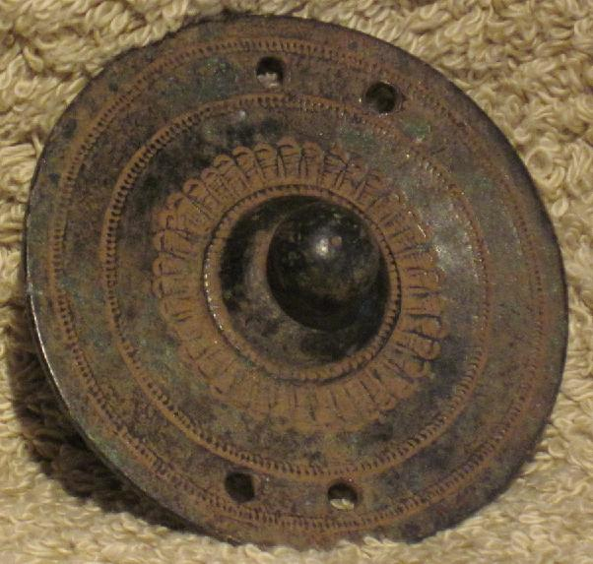

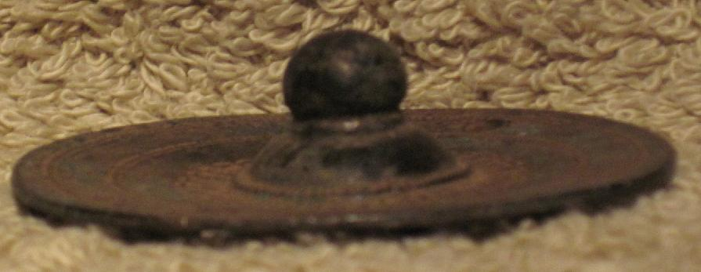

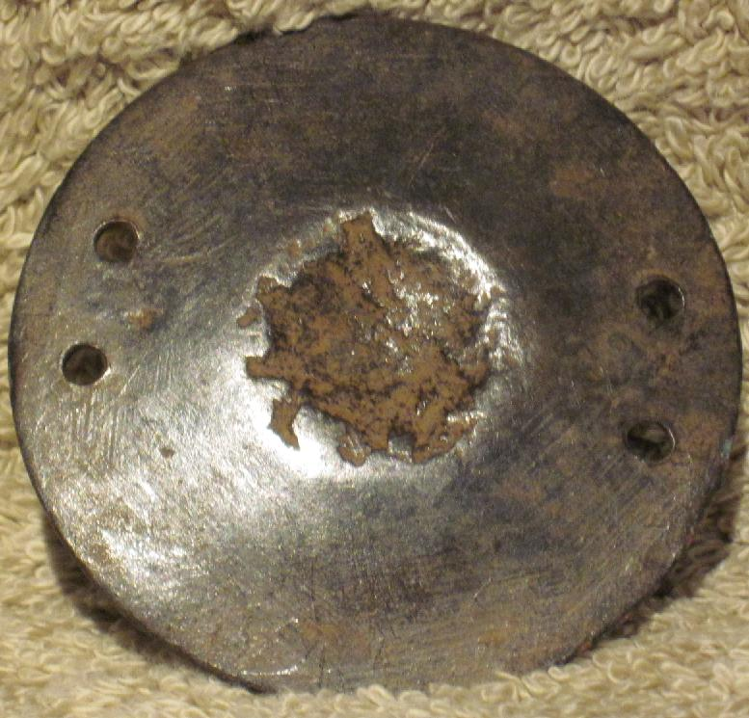

Figs. 1-3. Benin-Gorget-Bronze-Shield

Case no.: 6

Accession Number: A000

Formal Label: Benin-Gorget-Bronze-Shield

**Display Description:**

This bronze disk would have been affixed as an apotropaic gorget to royal regalia as an appurtenance designed to emulate a shield to protect the wearer.

**LC Classification:**  N7399

Date or Time Horizon: 1400 CE

Geographical Area: Djougou, Benin, Nigeria

**Map:**

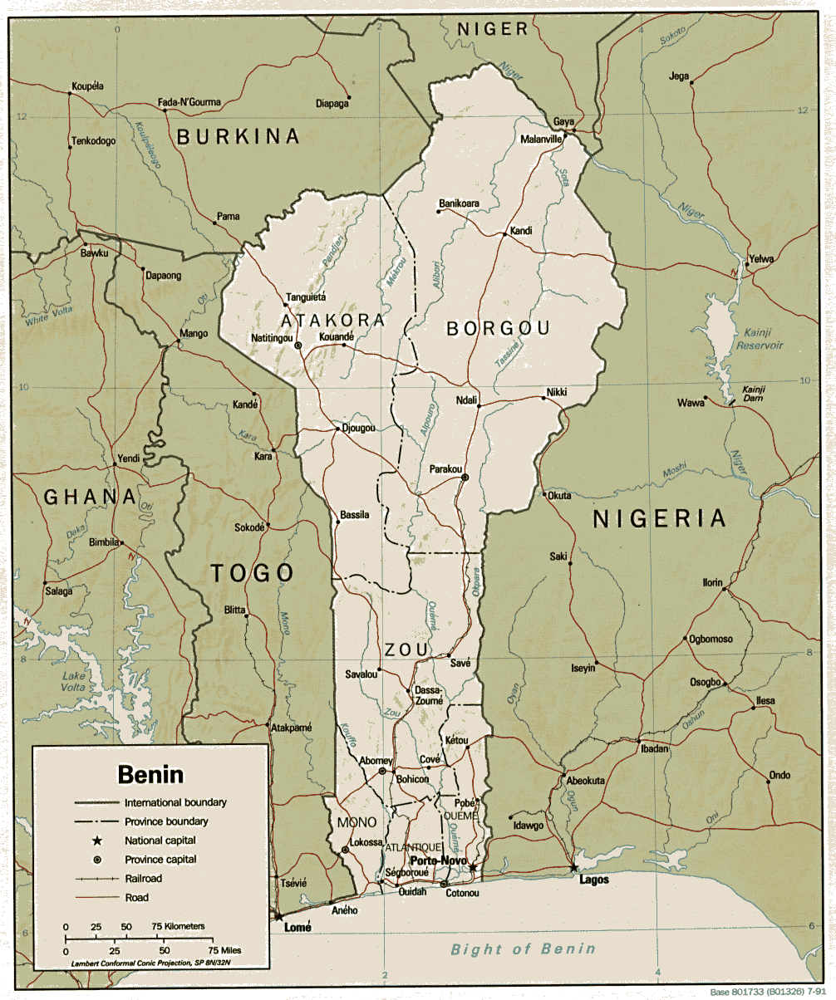

**Fig. 4. Map of Benin. From https://www.africa.upenn.edu/CIA_Maps/Benin_19841.gif**

**GPS coordinates:** 9°42'0"N, 1°40'0"E

Cultural Affiliation: Benin

Media: Bronze

Dimensions: 2.25 in. dia.

Weight:

Condition: original

Provenance: Djougou, Benin, Nigeria

**Discussion:**

**References:**

Ezra, Kate. 1992. *Royal art of Benin: the Perls collection*. New York: Metropolitan Museum of Art: Distributed by H.N. Abrams.

Kaplan, Flora S. 1981. *Images of power: art of the royal court of Benin: exhibition dates at New York University, the Grey Art Gallery, January 23-February 21.* [New York]: New York University.

M'Bow, Babacar and Osemwegie Ebohon. 2005. *Benin: A kingdom in bronze, the royal court art.* Ft. Lauderdale, FL: African American Research Library and Cultural Center, Broward County Library.

National Museum of African Art (U.S.). 1987. *Royal Benin art in the collection of the National Museum of African Art.*Washington, D.C.: Published for the National Museum of African Art by the Smithsonian Institution Press.